**Data Analysis**

**SQL PROJECT**

**OLYMPIC GAMES**



**Project Overview - :**

The Olympics Data Analysis Project aims to explore and analyse historical data related to the Olympics Games.

Olympic Games data, from Athens1896 to Rio 2016.

The file Athlete events contain 271116 rows and 15 columns.

**The columns are -:**

1. ID Unique number
2. Name Athlete’s Name
3. Sex M or F
4. Age int
5. Height in cm
6. Weight in kg
7. Team Team name
8. NOC National Olympic Committee-code
9. Games Game name
10. Year int
11. Season Summer or Winter
12. City City name
13. Sport Sport name
14. Event Event name
15. Medal Medal name

Now we will start our analysis :

1. **Show how many medal counts present for entire data.**

Query:

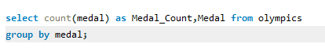

Result:

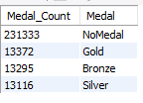

1. **Show count of unique sports present in Olympics.**

Query :

C:\Users\HP\Pictures\2q.png

Result:



1. **Show how many different medals won by team India.**

Query:

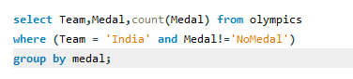

Result:

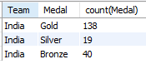

1. **Show event wise medals won by India show from highest to lowest medals won in order.**

Query:

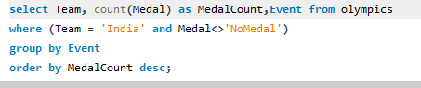

Result:

|  |  |  |
| --- | --- | --- |
| Team | Medal Count | Event |
| India | 173 | Hockey Mens Hockey |
| India | 7 | Alpinism Mixed Alpinism |
| India | 2 | Shooting Mens Air Rifle 10 metres |
| India | 2 | Wrestling Mens Welterweight Freestyle |
| India | 2 | Badminton Womens Singles |
| India | 1 | Wrestling Mens Lightweight Freestyle |
| India | 1 | Wrestling Mens Bantamweight Freestyle |
| India | 1 | Boxing Womens Flyweight |
| India | 1 | Shooting Mens RapidFire Pistol 25 metres |
| India | 1 | Wrestling Womens Lightweight Freestyle |
| India | 1 | Weightlifting Womens Light Heavy weight |
| India | 1 | Tennis Mens Singles |
| India | 1 | Athletics Mens 200 metres |
| India | 1 | Athletics Mens 200 metres Hurdles |
| India | 1 | Shooting Mens Double Trap |
| India | 1 | Boxing Mens Middleweight |

1. **Show event wise medals won by India in order of year.**

Query:

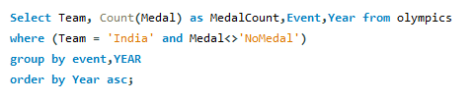

Result:

|  |  |  |  |
| --- | --- | --- | --- |
| Team | Medal Count | Event | Year |
| India | 1 | Athletics Mens 200 metres | 1900 |
| India | 1 | Athletics Mens 200 metres Hurdles | 1900 |
| India | 7 | Alpinism Mixed Alpinism | 1924 |
| India | 14 | Hockey Mens Hockey | 1928 |
| India | 15 | Hockey Mens Hockey | 1932 |
| India | 19 | Hockey Mens Hockey | 1936 |
| India | 20 | Hockey Mens Hockey | 1948 |
| India | 14 | Hockey Mens Hockey | 1952 |
| India | 1 | Wrestling Mens Bantamweight Freestyle | 1952 |
| India | 17 | Hockey Mens Hockey | 1956 |
| India | 13 | Hockey Mens Hockey | 1960 |
| India | 15 | Hockey Mens Hockey | 1964 |
| India | 16 | Hockey Mens Hockey | 1968 |
| India | 14 | Hockey Mens Hockey | 1972 |
| India | 16 | Hockey Mens Hockey | 1980 |
| India | 1 | Tennis Mens Singles | 1996 |
| India | 1 | Weightlifting Womens Light Heavy weight | 2000 |
| India | 1 | Shooting Mens Double Trap | 2004 |
| India | 1 | Shooting Mens Air Rifle 10 metres | 2008 |
| India | 1 | Wrestling Mens Welterweight Freestyle | 2008 |
| India | 1 | Boxing Mens Middleweight | 2008 |
| India | 1 | Wrestling Mens Lightweight Freestyle | 2012 |
| India | 1 | Boxing Womens Flyweight | 2012 |
| India | 1 | Wrestling Mens Welterweight Freestyle | 2012 |
| India | 1 | Shooting Mens RapidFire Pistol 25 metres | 2012 |
| India | 1 | Shooting Mens Air Rifle 10 metres | 2012 |
| India | 1 | Badminton Womens Singles | 2012 |
| India | 1 | Wrestling Womens Lightweight Freestyle | 2016 |
| India | 1 | Badminton Womens Singles | 2016 |

1. **Show country who won maximum medals.**

**Query:**

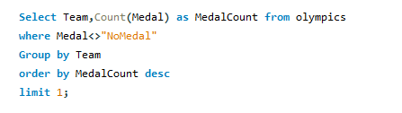

**Result:**



1. **Show top 10 countries who won Max medal**.

Query:

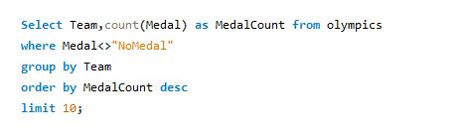

Result:

|  |  |
| --- | --- |
| Team | Medal Count |
| United States | 5219 |
| Soviet Union | 2451 |
| Germany | 1984 |
| Great Britain | 1673 |
| France | 1550 |
| Italy | 1527 |
| Sweden | 1434 |
| Australia | 1306 |
| Canada | 1243 |
| Hungary | 1127 |

1. **Show in which year did United States won most gold medal.**

Query:

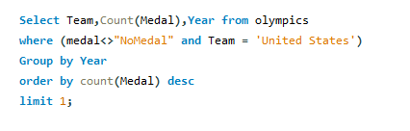

Result:

|  |  |  |
| --- | --- | --- |
| Team | Count(Medal) | Year |
| United States | 359 | 1984 |

1. **In which sports United States has most medals.**

Query:

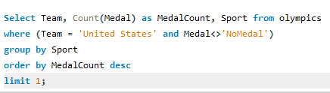

Result:

|  |  |  |
| --- | --- | --- |
| Team | Medal Count | Sport |
| United States | 1071 | Athletics |

1. **Find top 3 players who won most medals along with their sports and country**.

Query:

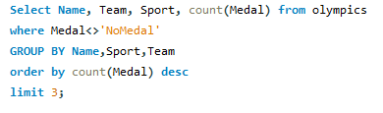

Result:

|  |  |  |  |
| --- | --- | --- | --- |
| Name | Team | Sport | count(Medal) |
| Michael Fred Phelps II | United States | Swimming | 28 |
| Larysa Semenivna Latynina Diriy | Soviet Union | Gymnastics | 18 |
| Nikolay Yefimovich Andrianov | Soviet Union | Gymnastics | 15 |

1. **Find Top 7 players with most medals (Gold+Silver+Bronze) in Basketball also show their country**.

Query:

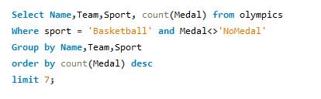

Result:

|  |  |  |  |
| --- | --- | --- | --- |
| Name | Team | Sport | count(Medal) |
| Teresa Edwards | United States | Basketball | 5 |
| Carmelo Kyan Anthony | United States | Basketball | 4 |
| Lauren Elizabeth Jackson | Australia | Basketball | 4 |
| Kristi Lee Harrower | Australia | Basketball | 4 |
| Tamika Devonne Catchings | United States | Basketball | 4 |
| Sergey Aleksandrovich Belov | Soviet Union | Basketball | 4 |
| Suzanne Brigit Sue Bird | United States | Basketball | 4 |

1. **Find out the count of different medals of the top basketball player Teresa Edward.**

Query:

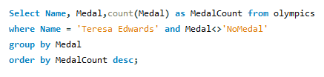

Result:

|  |  |  |
| --- | --- | --- |
| Name | Medal | MedalCount |
| Teresa Edwards | Gold | 4 |
| Teresa Edwards | Bronze | 1 |

1. **Find out medals won by male, female each year.**

Query:

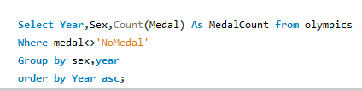

Result:

|  |  |  |
| --- | --- | --- |
| Year | Sex | Medal Count |
| 1896 | M | 143 |
| 1900 | M | 591 |
| 1900 | F | 13 |
| 1904 | M | 476 |
| 1904 | F | 10 |
| 1906 | F | 6 |
| 1906 | M | 452 |
| 1908 | M | 815 |
| 1908 | F | 16 |
| 1912 | M | 911 |
| 1912 | F | 30 |
| 1920 | M | 1264 |
| 1920 | F | 44 |
| 1924 | M | 910 |
| 1924 | F | 52 |
| 1928 | F | 103 |
| 1928 | M | 720 |
| 1932 | M | 671 |
| 1932 | F | 68 |
| 1936 | M | 928 |
| 1936 | F | 97 |
| 1948 | M | 871 |
| 1948 | F | 116 |
| 1952 | M | 875 |
| 1952 | F | 158 |
| 1956 | M | 872 |
| 1956 | F | 171 |
| 1960 | F | 195 |
| 1960 | M | 863 |
| 1964 | F | 246 |
| 1964 | M | 969 |
| 1968 | M | 995 |
| 1968 | F | 261 |
| 1972 | F | 295 |
| 1972 | M | 1119 |
| 1976 | F | 440 |
| 1976 | M | 1091 |
| 1980 | F | 485 |
| 1980 | M | 1117 |
| 1984 | F | 548 |
| 1984 | M | 1150 |
| 1988 | F | 617 |
| 1988 | M | 1228 |
| 1992 | F | 691 |
| 1992 | M | 1339 |
| 1994 | M | 223 |
| 1994 | F | 108 |
| 1996 | F | 764 |
| 1996 | M | 1078 |
| 1998 | F | 189 |
| 1998 | M | 251 |
| 2000 | F | 880 |
| 2000 | M | 1124 |
| 2002 | M | 270 |
| 2002 | F | 208 |
| 2004 | F | 898 |
| 2004 | M | 1103 |
| 2006 | M | 295 |
| 2006 | F | 231 |
| 2008 | F | 932 |
| 2008 | M | 1116 |
| 2010 | M | 291 |
| 2010 | F | 229 |
| 2012 | M | 1023 |
| 2012 | F | 918 |
| 2014 | F | 265 |
| 2014 | M | 332 |
| 2016 | M | 1054 |
| 2016 | F | 969 |

The Analysis, I was able to gain a deeper understanding of the history of the Olympics and the performance of countries and athletes over the past 120 years . By using SQL, I was able to extract valuable insights from the data.

**SUMMITTED BY:**

KHUSHI BHARTI